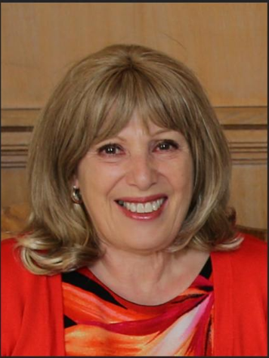

THE ELTC SAFEGUARDING / WELFARE OFFICER IS
KAREN BENARDOUT
PH: 07930220225
EMAIL:Safeguardingelstreetennis@yahoo.com
IF YOU HAVE ANY CONCERNS ABOUT A CHILD OR VULNERABLE ADULT, THE CLUB EXPECTS YOU TO EITHER NOTIFY THE WELFARE OFFICER, CONTACT THE LTA SAFEGUARDING TEAM, CONTACT THE NSPCC OR IN THE EVENT OF AN EMERGENCY CALL THE POLICE.
LTA Safeguarding Team
020 8487 7000 / CSOHERTFORDSHIRE@GMAIL.COM
NSPCC Contact:​
If you have concerns about a child's safety and wellbeing, including a child in your family, please call us on 0808 800 5000 and one of our advisors can help you. Alternatively, you can text us on 88858 or email us at help@nspcc.org.uk.
If you think a child is in immediate danger, do not delay – call the police on 999.

