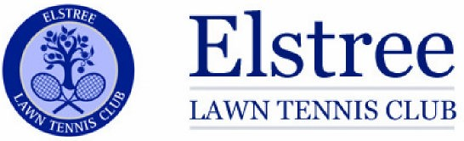
Adult Membership Application Form 2024/5
To become a member of Elstree Lawn Tennis Club and British Tennis Membership, please complete this form and return to the Membership Secretary Myra Rosen 11 Deacons Hill Road, Elstree, Herts WD6 3HY, Tel 020 8953 5795 / 07986 134 403. myrarosen@btopenworld.com.
Title: | Gender (optional):
First Name:  Surname:  Date of Birth: | Address:  Town:  Post Code:
Home Phone:  Mobile:  Email: | Are you already a member of the LTA  Yes/No  If Yes, please advise Membership #
Please let us know how you first heard about ELTC. | Friend/website/banner/other:  If other, please detail.

Membership Categories:

Adult Member | £220 | Social Member non playing | £20
Student Member 17-24 (In full time education) | £80
Junior Member - 16 and under | £50

Membership fees are payable annually on 1 May. New members joining after this date will be charged a pro rata fee, as set by the Membership Secretary. All applications will be considered by the Club’s Committee and their decision is final.
Method of Payment: Cheque or Bank Transfer (please delete) Amount £………
Cheques payable to: Elstree Tennis Club
Bank Transfer to: Sort Code 20-74-09, Account 10147435. Ref: Members Full Name
I have read, understood and agree to abide by the Membership Rules and Safeguarding policies set out on the Elstree Lawn Tennis Club website www.elstreetennis.com.
I agree that I will not play at the club if I am unwell, injured or advised by a medical professional not to do so.

Signature ………………………………………………………………

Name and Date ……………………………………………………

